Soal
1.) Program

Looping (For)
Source Code

soal1.java
public class soal1{
public static void main(String []args){
for(int i=0;i<25;i++){
System.out.println("Universitas pancasila fakultas teknik jurusan teknik informatika");
}
}
}

Screenshoot
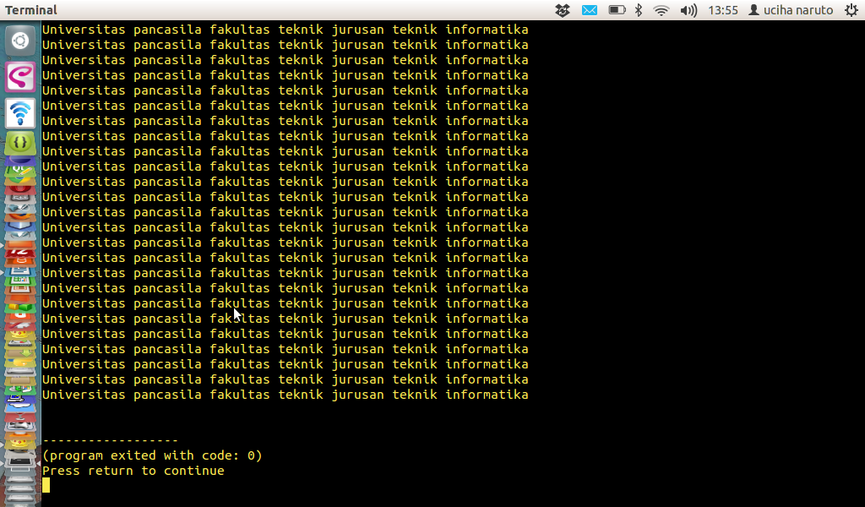

Looping (Do ..While)
Source Code

soal1.java
public class soal1{
public static void main(String []args){
for(int i=0;i<25;i++){
System.out.println("Universitas pancasila fakultas teknik jurusan teknik informatika");
}
}
}

screenshoot
2. Looping (For...next)
Source Code

soal2.java
public class soal2{
public static void main(String []args){
for(int i=0;i<20;i++){
System.out.println(i+1);
}
}
}

screenshoot
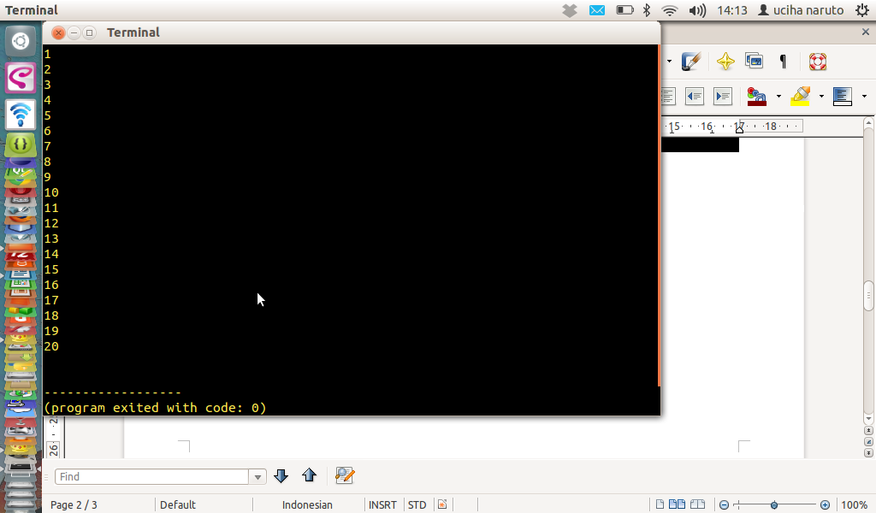
Looping (Do ..While)
Source Code
public class soal2{
public static void main(String []args){
for(int i=0;i<20;i++){
System.out.println(i+1);
}
}
}

screenshoot
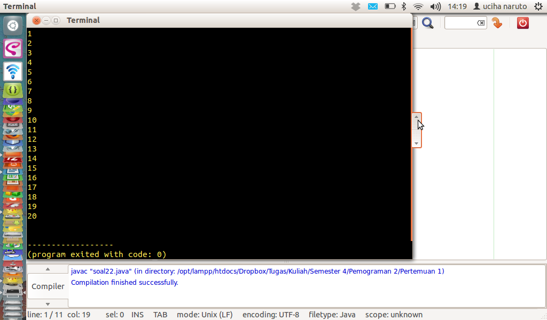

Looping (For)
Source Code

soal3.java
public class soal2{
public static void main(String []args){
for(int i=0;i<20;i++){
System.out.println(i+1);
}
}
}

screenshoot
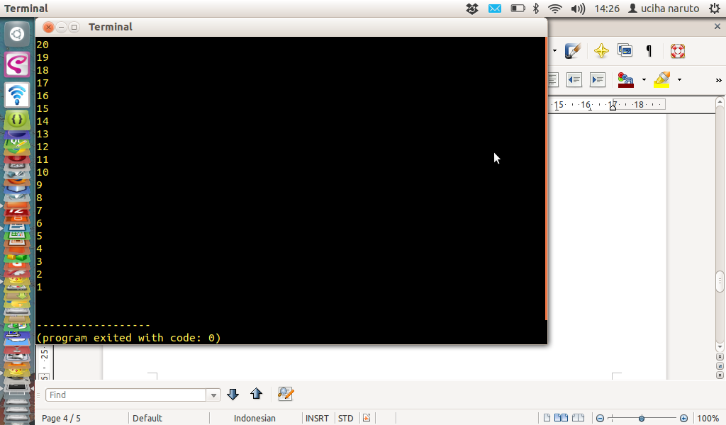

Looping (Do ..While)
Source Code
public class soal32{
public static void main(String []args){
int i=20;
do
{
System.out.println(i);
i--;
}while(i>0);
}
}

screenshoot
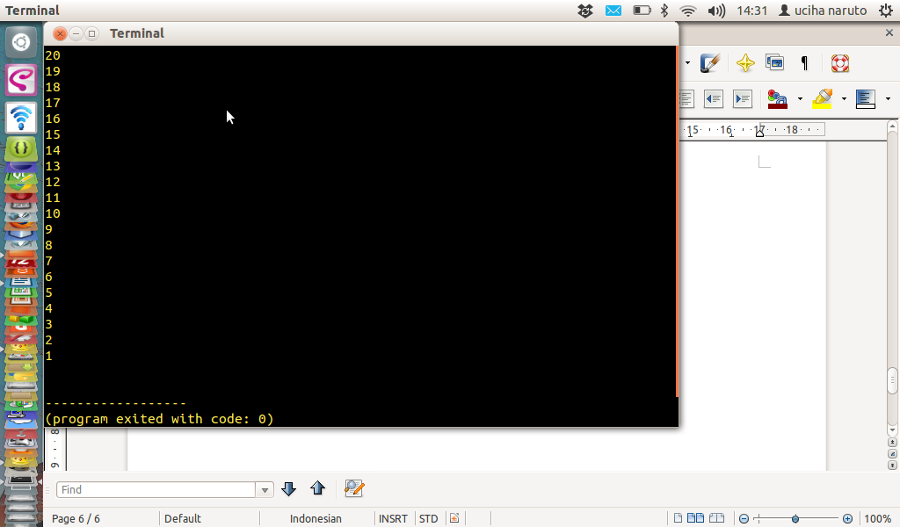

4. Looping (Do ..While)
Source Code
soal4.java

public class soal4{
public static void main(String []args){
int i=20;
do
{
System.out.println(i);
i--;
}while(i>0);
}
}

screenshoot
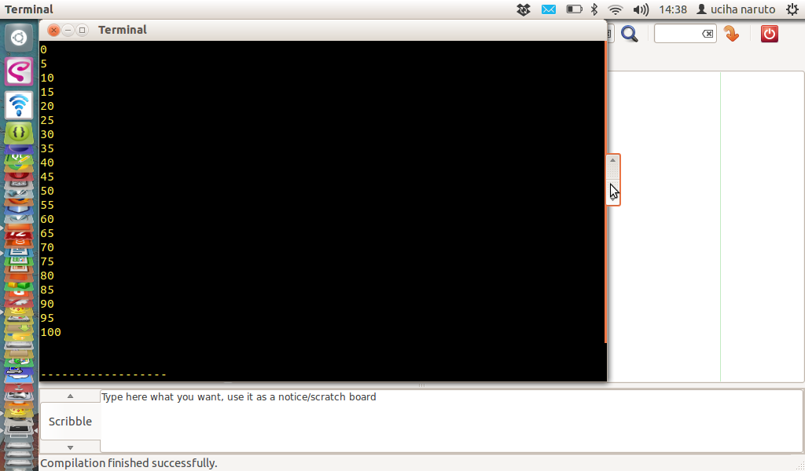

Looping (For)
Source Code

soal42.java
public class soal42{
public static void main(String []args){
for(int i=0;i<=100;i=i+5){
System.out.println(i);
}
}
}

screenshoot
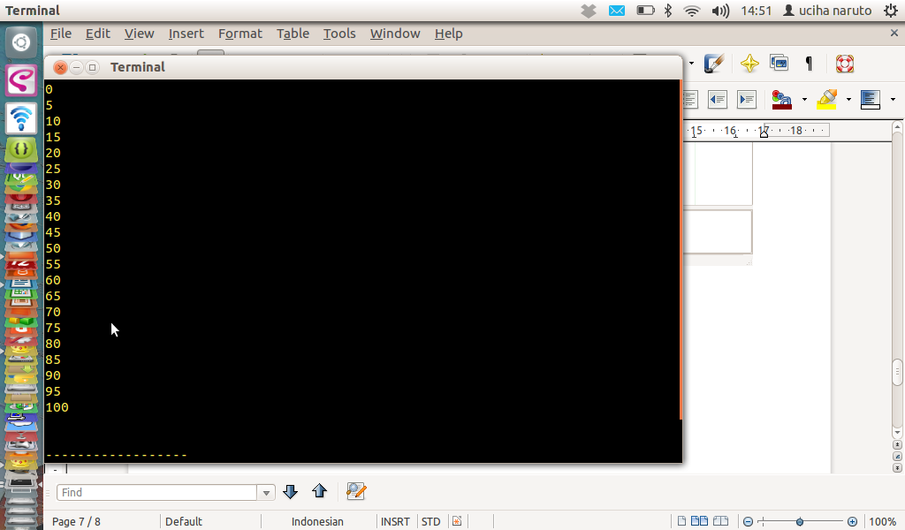

Looping (For)
Source Code

soal5.java

public class soal5{
public static void main(String []args){
for(int i=100;i>=0;i=i-5){
System.out.println(i);
}
}
}

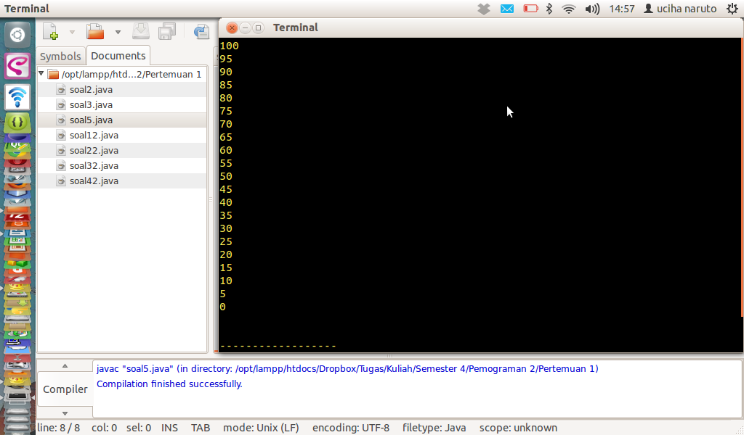

Looping (do...while)
Source Code
soal52.java
public class soal52{
public static void main(String []args){
int i=100;
do
{
System.out.println(i);
i=i-5;
}while(i>=0);
}
}
screenshoot
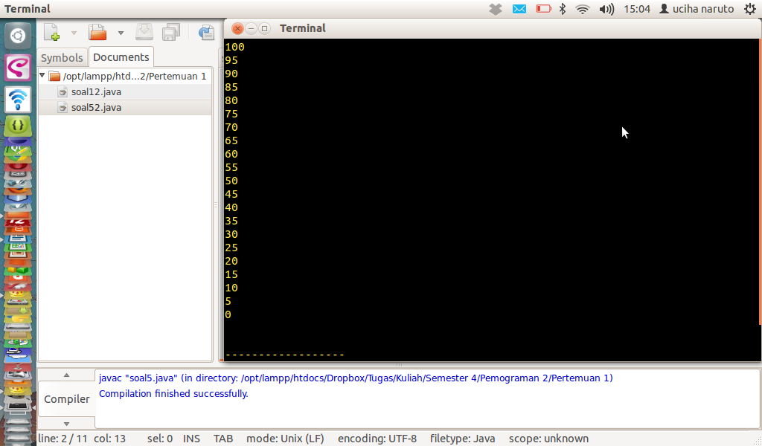

6. soal3_06.java
public class soal3_06 {

/**
* @param args the command line arguments
*/
public static void main(String[] args) {
long n = 1;
int k = 0;
int i = 0;

do{
i=0;
do{
n = n*2;
System.out.println(n);
i++;
}while(i<4);
k++;
}
while(k<2);
}
}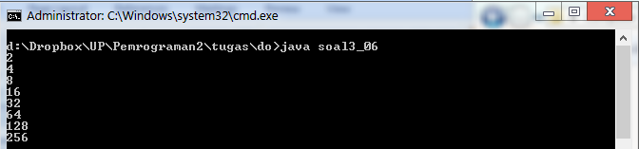

soal3_06b.java
public class soal3_06b {

/**
* @param args the command line arguments
*/
public static void main(String[] args) {
long n = 1;

for(int k = 0; k<2; k++){
for(int i = 0; i<4; i++){
System.out.println(n);
n = n*2;
}
}
}
}
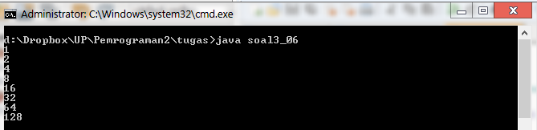

7.
saol7.java
public class soal7{
public static void main(String []args){
int n=1;
for(int k=0;k<2;k++){
for(int i=0;i<4;i++){
n=n*2;
System.out.println(n);
}
}
}
}
screenshoot
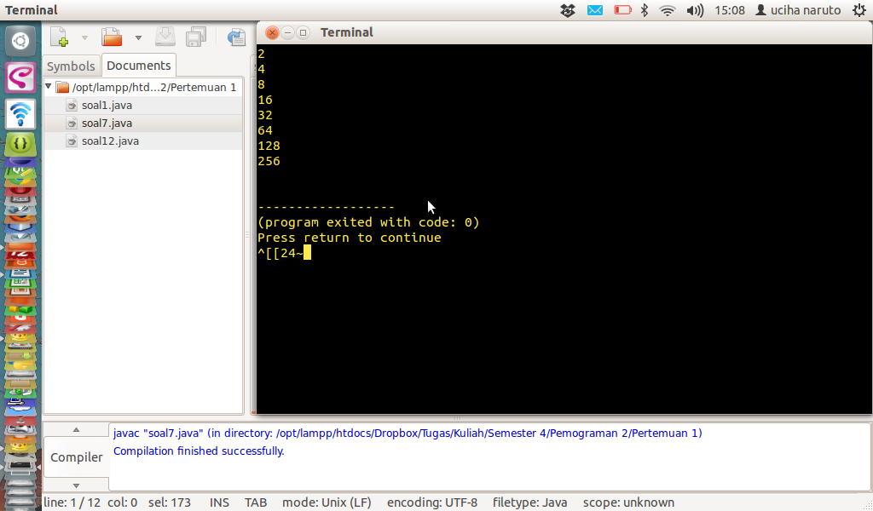

soal 72.java
public class soal72{
public static void main(String []args){
int n=1;
int k=0;
int i;
do
{
i=0;
do{
System.out.println(n);
n=n*2;
i++;
}while(i<4);
}while(k<2);
}
}

